Members:

Joel Harsent - 20413335  
Josh -   
Louise Anderson – 20422051

Mario - 20407725

Max

CSY2027 GROUP 2

Contents

1. Introduction 2

2. Aim and Objectives 2

3. Requirements Gathering 3

3.1. Interviews 3

3.1.1. Interview with customer 3

3.1.2. Interview with business owner 4

3.1.3. Summary of findings 5

3.1.4. List of Requirements 5

**3.2.** Questionnaires 6

3.3. Comparable systems 7

3.4. Build 11

3.5. Resources 12

3.6. Legislation 13

3.6.1 PCI compliance 13

3.6.2. GDPR 13

3.6.3. The Equality Act 14

3.7. Problem domain 14

4. Design 15

4.1. Diagrams 15

4.2. Wireframes 19

4.3. ERD 19

Figure 1: Comparable systems rococo chocolates 8

Figure 2 Comparable systems the chocolate shop 9

Figure 3 Comparable systems thorntons 10

Figure 4 Comparable systems hotel chocolat 11

Figure 5 Navigation flowchart 16

Figure 6 Registration activity diagram 17

Figure 7 Payment activity diagram 18

Figure 8 Payment sequence diagram 19

Figure 9 Edit product sequence diagram 19

Figure 10 Submit a query sequence diagram 20

Figure 11 Register wireframe 21

Figure 12 Login wireframe 22

Figure 13 Homepage wireframe 23

Figure 14 Products wireframe 24

Figure 15 About us wireframe 25

Figure 16 White chocolate category wireframe 27

Figure 17 Vegan and gluten free category wireframe 28

Figure 18 Homepage navigation bar options wireframe 29

Figure 19 Milk chocolate category wireframe 30

Figure 20 Gift boxes category wireframe 31

Figure 21 Dark chocolate category wireframe 32

Figure 22 Contact us and social media wireframe 33

Figure 23 Basket wireframe 34

Figure 24 Master admin dashboard wireframe 36

Figure 25 Admin dashboard wireframe 37

Figure 26 Master admin add account wireframe 38

Figure 27 Add products wireframe 39

Figure 28 Mobile register wireframe 40

Figure 29 Mobile login wireframe 41

Figure 30 Mobile homepage wireframe 42

Figure 31 Mobile vegan category wireframe 43

Figure 32 Mobile basket wireframe 44

Figure 33 Mobile contact us wireframe 45

Figure 34 Mobile admin dashboard 46

Figure 35 ERD 47

Table 1 - Questionnare 7

Table 2 Comparable systems ratings 12

# Introduction

Northampton Speciality Chocolates are a new chocolate retailer specialising in selling luxury chocolates online. They are a new business who wish to gain customers by creating a website for customers to view products, monitor past and current orders, ease their payment process, manage social media and allow staff to monitor sales and staff.

Impact developments have been approached to create a fully functional e-commerce website, which will be selling specialty chocolates where customers will be able to buy and view different categories of chocolate on the website.

# Aim and Objectives

The aim of the e-commerce website is to enhance visitor experience and increase revenue by implementing a new system which can improve both visitor experience and staff efficiency.

By improving the usability of the website customers will be able to effortlessly navigate the website and purchase goods, encouraging them to return to become repeat customers and improving sales. Additional features such as social media links and management will encourage new customers. Staff accounts and dashboard will make it easier for staff to manage the website and view sales and purchase history, making the website and business easier to maintain.

Objectives:

* Formal interviews with the client in-order to determine what the problem is and other parameters within the problem domain
* Comparing similar systems to assess their upsides and downsides in an attempt to create a new system which adopts the upsides and remediates the downsides of the comparable application
* Conducting questionnaires on a larger array of people including Northampton Speciality Chocolates potential customers
* Investigate performance and functional requirements required for the new website
* Create flowcharts of website functionality and navigation
* Create wireframes of the website with a new logo and consistent layout
* Present a functioning website prototype that meets all assessment requirements by May 22nd with a budget £9000

# Requirements Gathering

## Interviews

### Interview with customer

Q. What technology do you own e.g Personal computer, laptop, smartphone, tablet etc…

1. I own many devices which include a personal computer and a smartphone.

Q. Do you often buy specialised chocolate off e-commerce sites?

1. I often buy chocolate but do not have one website where I can focus on specialised chocolate.

Q. Do you look at chocolate products through social media?

1. I only look if they appear as adverts on the social media applications otherwise I would not personally search for chocolate.

Q. Would having different categories and a search bar be useful for browsing the chocolate?

1. Yes this would be really useful because I am vegan and being able to search and look at categories of the chocolate is a huge benefit.

Q. Would you be interested in being able to register an account?

1. Yes I would be interested as this would make saving personal information easier and less hassle.

Q. Would you like to see the previous order and be able to reorder those? .

1. Yes this would be really useful as it would make it easier to quickly repurchase an item.

Q. Would you be interested in a loyalty scheme?

1. Yes this would be useful and would make me keep buying chocolate from the website.

Q. Would a contact form page be useful?

1. I would find this useful as it would make it easier for me to contact the business if there are any issues with orders or problems with the site.

### Interview with business owner

Q1 Do you already have a logo which you would like to use?

1. No, we do not have a logo yet.

Q1a Do you have a general idea for the design of the logo?

1. Small, friendly looking logo with the company name visible.

Q2 What colours would you like the web application to use? (up to 2-3)

1. I don’t have any particular colours in mind, I’d like it to be a design with light colours, but nothing too flashy.

Q3 Would you like the web application to be image-heavy?

1. Yes, I would like to have images throughout the pages showing off different products.

Q4 Where will the images come from?

1. I will provide you with some images I would like you to use.

Q5 What features would you like to include?

1. I would like to have user accounts, admin accounts, contact page for customers, social media links, navigation bar and different categories for products. (add more here if needed)

Q6 Will you be shipping your products?

1. Yes, customers will be offered shipping.

Q6a Will you serve customers internationally?

1. Shipping will only be for people inside of the UK

Q7 What payment options would you like to offer?

1. I would like customers to use credit and debit card, as well as Paypal.

Q8 Can customers create an account?

1. Yes, each customer can create a user account

Q8a What can customers do with their user account? (Order tracking?)

1. Customers can track orders, view their order history and get personalised recommendations of products.

Q9 How many members of staff will require a login?

1. At the moment, just myself. However, I would like to be able to add admin accounts through the website if I decide to give the permissions to anyone else.

Q10 What should members of staff have permission to do on the web application?

1. People with an administrator login need to be able to add products to the page, add new categories and be able to see any responses in the ‘Contact Us’ form

Q11 Who are your competitors?

1. Our main competitors are Thorntons and Hotel Chocolat.

Q12 Is there anything you definitely don’t want us to include on the web application?

1. No flashy colours and the design needs to be fitting with our brand

### Summary of findings

Based on the findings of a potential customer, impact development has decided to make the web application more user-friendlyby introducing a loyalty scheme and providing categories and a search bar for customers with allergies, making navigation of the products and selecting the correct chocolate much easier. Other elements that would be beneficial to include in the online application include a customer contact page and ensuring that the web application is compatible with a variety of devices.

After interviewing the business owner, we have found that they do not currently have a logo yet. They would like to have a small simple logo, which is friendly looking and has the company name visible. There are no particular colours which should be used for the web application, it just needs to be fitting with the brand, however they do not want any flashy colours. The business owner will also provide images to be used on the website, as they would like the website to have many pictures showing off different products. The main features the web application should have are, user/admin accounts, “Contact Us” page with social media links and a navigation bar at the top for easy use, which includes different categories the user can click on. The business will only provide shipping for inside of the UK and the payment options used should be debit/credit card and PayPal. Customers need to be able to track orders, view their order history and get personalised recommendations based on their history. Only the business owner will need an admin account at the moment, however they would like to be able to add admin accounts in the future. Admin accounts need to have permission to add products and categories to the web application and view any responses to the contact form on the “Contact Us” page. The main competitors of the business are Thornton’s and Hotel Chocolat.

### List of Requirements

These are the requirements for the web application as instructed by the client.

* Create logo
* Fitting colour scheme
* Include a lot of images
* Not a lot of text
* Include contact page, navigation bar, accounts
* Only delivers to UK
* Customer account can track orders, view order history and receive recommendations based on history
* Business owner needs to be able to add, edit and delete admin accounts
* Admin accounts can add products and categories and respond to queries from customers.

## Questionnaire

100 Potential Customer Responses

Table - Questionnaire

|  |  |  |  |  |
| --- | --- | --- | --- | --- |
| **Question** | **Strongly disagree** | **Disagree** | **Agree** | **Strongly Agree** |
| I often buy food online |  | 10% | 70% | 20% |
| I would buy speciality chocolates online on a regular basis | 60% | 30% | 10% |  |
| I would buy speciality chocolates online for special occasions e.g birthday | 5% | 5% | 60% | 30% |
| An website loyalty scheme would encourage me to buy from a specific website |  | 40% | 30% | 30% |
| An active social media presence dictates where I shop online | 40% | 30% | 30% |  |
| When buying online I find it useful to browse by different categories |  |  | 30% | 70% |
| When buying online I find it useful to be able to use a search bar to find the product I want |  |  | 20% | 80% |
| An easy to access shopping cart that allows me to add and remove products is essential |  |  | 10% | 90% |
| A “contact us” section that allows communication with the business is essential |  |  | 60% | 40% |
| I would prefer if a seller’s website showed the location of the store on a google map so I could shop in person rather than online |  | 45% | 45% | 10% |
| I would recommend a chocolate buying website to my friends if it were good enough |  | 5% | 50% | 45% |
| I would enjoy a weekly newsletter emailed to me with news and vouchers | 70% | 25% | 5% |  |
| I would enjoy a page after in log in with news and vouchers |  |  | 20% | 80% |
|  |
| An option to review products is essential in deciding what product to buy |  |  | 20% | 80% |  |
| When viewing a homepage of a website I would prefer to see one main image and browsing options |  | 25% | 45% | 30% |  |
| When viewing a homepage of a website I would prefer to see a selection of items, deals and news | 25% | 50% | 25% |  |  |
|  |  |  |  |  |  |
| Additional comments: |  | | | |  |
|  |  |

## Graphical user interface Description automatically generatedComparable systems

Figure : Comparable systems rococo chocolates

Rococo Chocolates -<https://www.rococochocolates.com/>

The website is displayed with a logo and navigation bar on the top of the page and has a banner underneath, the main layout under the header is then displayed in a grid layout. This then keeps the same design throughout the website on each webpage. With the website keeping the navigation bar at the top, it provides a drop-down menu, search bar, sign in, and basket. This makes the website easier to navigate.

Negative aspects of this website are that a popup appears in the middle and bottom right of the screen, this then makes the website feel clustered when trying to view the different webpages. Another negative is that there is not a clear place to register, although there is a sign in on the navigation bar, there is not one clear location where the registration is. Furthermore, once clicking on the product there is a lot of information, this may make it confusing for customers when viewing products and understanding what the company is selling to them.

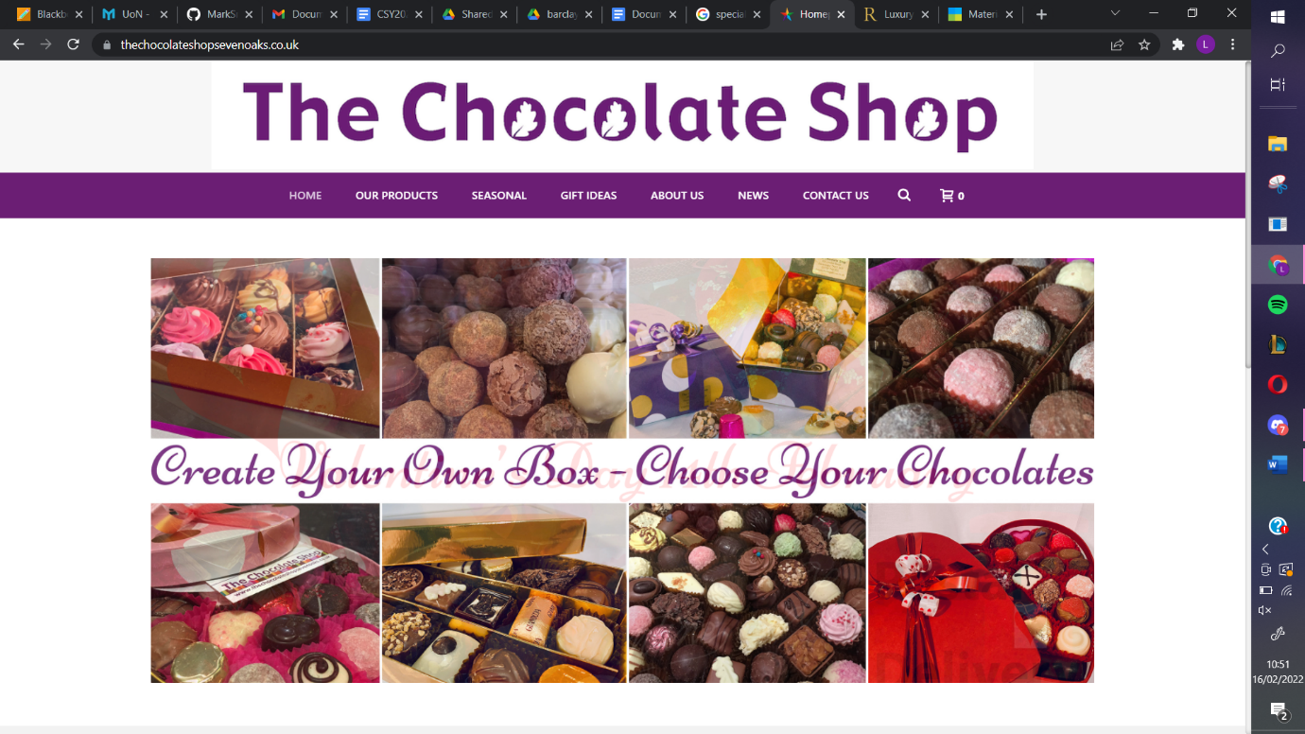The chocolate shop -<https://thechocolateshopsevenoaks.co.uk/>

Figure Comparable systems the chocolate shop

The website displays a logo and navigation bar in the header. Underneath the header the website is then displayed with a consistent design of a grid layout which can be seen on most pages. Products can also be removed once added into the basket.

Negative aspects of the website are that there is not a login system, this causes problems for customers who want to save an item or personal information when buying products. Another issue is that there are inconsistencies of dates and a broken webpage on the website, therefore this means that the maintenance is very low when updating this website. Furthermore, another negative aspect is that on some web pages the page does not fit on the whole screen. On the contact page there is no real way of entering information other than sending an email.

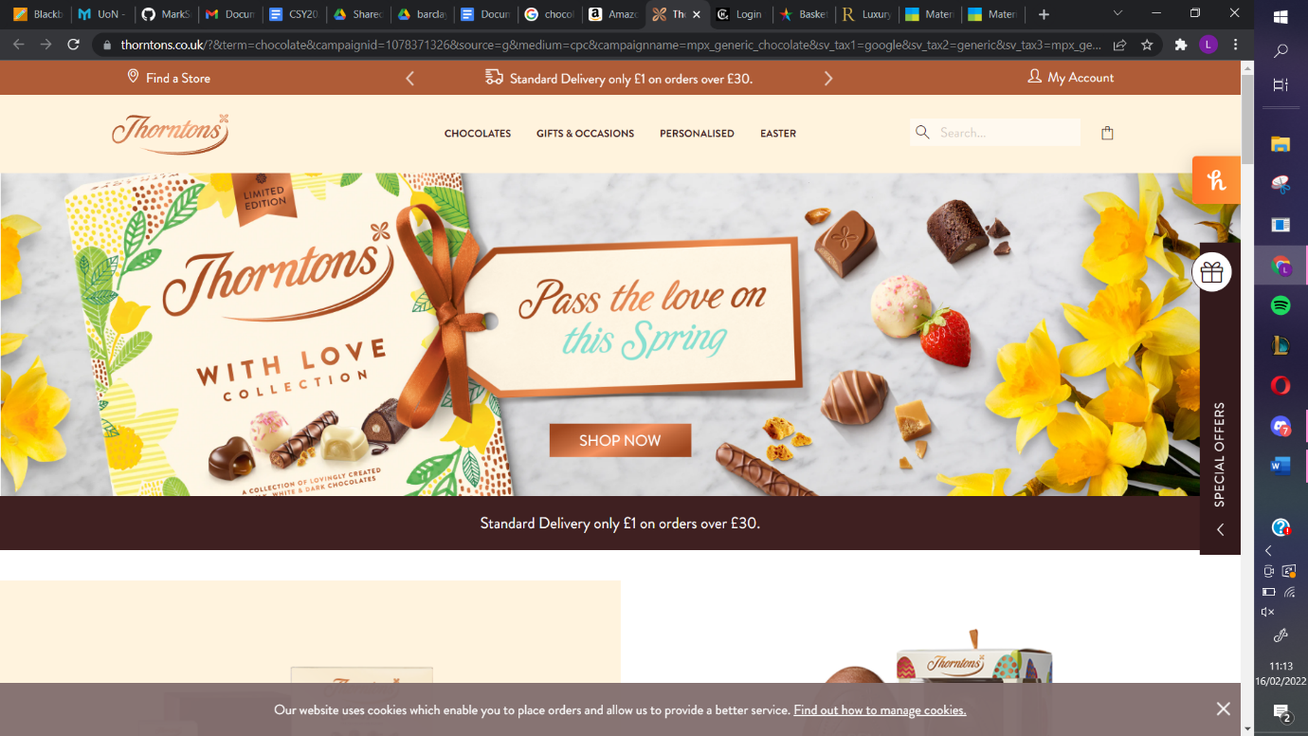

Figure Comparable systems thorntons

Thorntons - <https://www.thorntons.co.uk/>

Thornton’s website has the same design and colours throughout all the different pages. There is a navigation bar at the top to link you to all their different products. When scrolling down further on the website it is nice for users to look at with different images of products and headings that are easy to read. The website displays links to their social media and contact page, which makes it easy for you to contact them directly and keep updated with any news. Users can create an account or log in, allowing them to view their recent purchases or track orders. The website has a ‘find your store’ function which asks for your postcode and shows the nearest store to you. Users are able to view this website on mobile phones as well, with a consistent layout.

However, some of the negatives are that just shortly after entering the website, a pop up appears asking the customer to sign up to their newsletter, which may put some people off from the start. On the edge of the right screen, there is a special offers tab which is not easily visible at all, and if you accidentally click the cross on it to remove it, it does not come back, even after reloading the page. It is also not easy to find the special offers anywhere else on the website. The find a store function a lot of the time will not show a store near you unless there is one very close to the post code you entered.

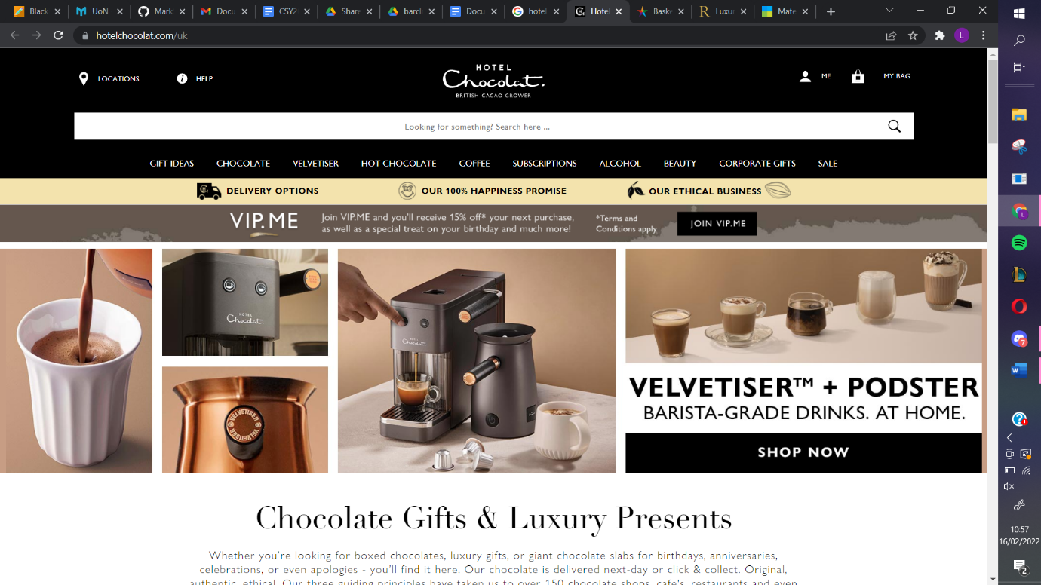

Figure Comparable systems hotel chocolat

Hotel Chocolat - <https://www.hotelchocolat.com/uk>

The Hotel Chocolat website has a consistent colour scheme throughout and a nice grid layout which is easy for any user to navigate. At the top of the page there is a navigation bar with drop down lists which link you to all the different products that the company offers as well as their subscription service. Each of these sections allow you to apply a filter to make sure you find what you are looking for. After scrolling down further there are more links to other products such as easter and Mother’s Day products, or chocolate gift boxes and gifts for couples, birthdays or weddings. The website makes it easy for users to login and register and this allows them to see their order history. It is also easy to get in contact with the company about any complaints or questions you may have.

However, there are also some negatives to this website. It has a lot of text, which makes it hard to focus on some of the aspects of the website and may make it confusing for some users. This could lead to them going to a competitor’s website that looks nicer. Another negative is that after a few minutes of scrolling, a pop-up appears asking you to sign up to their VIP subscription for a discount. When using different operating systems, if the website is not in Fullscreen, the navigation bar will not load properly.

**Summary**

Each of the comparable systems have their own strengths and weaknesses which have been highlighted in the descriptions. This has helped to realise which features should be included and what problems to look out for when developing the website, to provide the best possible experience for each user. Most of the systems had a consistent design throughout the pages, making it easy to use for the user. Each site has a navigation bar which clearly indicates each of the different sections of the website. In these sections, you can filter products to meet your needs. Users can create accounts to track orders and view their purchase history. Customers can also contact the support team with any queries they may have, either through the website or through social media, which is usually linked in a ‘Contact Us’ page on the website.

*(1 – not present, 2-Poor, 3-Average, 4 -Very Good, 5 Excellent)*

Table Comparable systems ratings

|  |  |  |  |  |
| --- | --- | --- | --- | --- |
| **Features** | **Rococo Chocolate** | **The Chocolate Shop** | **Hotel Chocolat** | **Thorntons Chocolate** |
| **Usability** | 3.5 | 3 | 2.5 | 3.5 |
| **Navigation** | 4 | 2 | 4 | 3 |
| **User-friendly** | 3 | 2 | 3 | 4 |
| **Additional features** | 4 | 2 | 4 | 4 |
| **Layout** | 3 | 3.5 | 4 | 4 |
| **Colours** | 4 | 2 | 3.5 | 5 |
| **Payment process** | 4 | 3 | 3 | 4 |
| **User account** | 4 | 1 | 5 | 4.5 |

## Build

**Programming language**

HTML, CSS, PHP, Javascript

**Database**

MYSQL

**Software Architecture**

E-commerce system architecture two tier architecture will be used. The website will have a client-side and server-side with a constant interaction between client and server.

**Supporting tools**

Google docs for collaborative report writing

Github for collaborative coding and note sharing

Discord and emails for group communication

Figma for wireframes

Trello for group task allocation

## Resources

**Software:**

-          Visual Studio Code is the software we will be using to code the web pages, using PHP for the functionality of the web pages including password hashing and database handling. Additionally, HTML will be used for the structure of the web pages and CSS will be used to style them, JavaScript will be used for the auto mail response for the ticketing system using the node.js library.

-          Figma will be used to create the wire frames for each webpage, which will show the page layouts and basic functionality of these pages.

-          Bootstrap is the framework we have decided to use to simplify and speedup development.

-          MySQL is the database management system that will be used to build the database structure and hold the users and admin data. Including the usernames, passwords, previous sales, items in stock and cart items.

-          Live Server is a plugin for Visual Studio Code that simulates a web server allowing the team to test the site throughout development.

-          Docker will be used to run a webserver on our machines capable of running the PHP scripts.

**Hardware:**

Each member of the team will be using a laptop with:

-          AMD Ryzen 3 3200U with on board graphics

-          8 GB of RAM

-          Windows 10 (64 Bit).

-          150 GB of Storage

## Legislation

### PCI compliance

PCI DSS stands for Payment Card Industry Data Security access. It is an information security standard for businesses that handle payments from credit cards from major brands. Following PCI ensures that organisations secure and protect credit card data cardholders provide that is transferred through card payment transactions.

To stay in PCI scope the above must be followed. Only necessary information should be stored, only limited admin can see credit card data and type of data can be limited and security should be maintained.

### GDPR

Data protection is the measures taken to protect an individual's personal information.  Personal data is information that can be used to identify someone, and the data protection act regulates how a person’s information is used by businesses. This applies to customers, clients, suppliers and staff.

 General Data Protection Regulation, or UK GDPR, is the piece of legislation that sets new standards for protecting personal data in the UK. It revolves around placing stricter limitations on the amount and type of data that organisations can keep on individuals. It is designed to give an individual more control over their own information.

Within the Data Protection Act there are 6 lawful reasons for processing data:

1. Contractual - To comply with employee obligations
2. Legitimate interests - used by companies to enhance and improve services to customers and employees.
3. Consent - For marketing, customers must give us permission to send marketing material direct to them
4. Legal obligation - to comply with the law
5. Vital interests – in the event of an emergency information could be shared to save your live
6. Public Task – this is sharing information to exercise laws. This does not apply to us as it would normally apply to public functions like the police force or council

Impact development is responsible for complying with these regulations therefore will only collect data necessary and for a specific purpose. The information stored will be used to process payments, delivery information and returning customer information for loyalty schemes.

### The Equality Act

The equality act protects people from discrimination, it applies to in their workplace, as a customer, businesses and the government. The equality act makes it illegal for anyone to be discriminated against because of their age, gender, sex, sexual orientation, disability, race or ethnicity, religion, pregnancy, or marital status. If a person is treated unfairly due to one of these reasons it is against the equality act and is unlawful discrimination.

## Problem domain

Managing sales

When establishing a new online business, it is crucial that members of staff can monitor sales and progress, this will help with managing the business as a whole as the business owner will be able to clearly view what products are doing well and to therefore sell more of, and what products are not doing well and therefore to remove. This would be implemented using an admin dashboard when an admin logs in. This will show the number of sales and allow for staff members to add and remove products for sale.

Gaining new customers

It is important to have a well-established brand and an eye-catching online store which will attract new customers to browse through the products on the website and make a purchase. Gaining new customers can also be accomplished by using advertising platforms such as Google ads. Social media is another great tool for advertising, which means that it is very important to be active on multiple different platforms and to engage with the communities to bring in new customers. Frequently posting images or updates about the company that interests the target market can lead them to clicking on the website and buying products that they like. Good customer service is important because people that get treated well are likely to leave a good review, which looks great for future customers, and they might also recommend you to friends and family which is another great way of gaining new customers. Discounts and sales can attract customers to buy multiple products in one go which is good for the business. A loyalty scheme for customers that frequently shop with us is another great way to ensure that they keep coming back and buy more.

Marketing and increasing sales

Marketing will mainly be done through social media advertising, as most people in the target market use it daily. It is important to consistently post, maybe once or twice a week, to keep people interested and to keep bringing in new customers. However, the quality of each post needs to be great each time too and there always needs to be something that stands out, because otherwise people will simply scroll past your post without giving it any attention.

Lack of computer expertise

​​Not everyone has the same amount of knowledge using technology, so it is vital that the web application is designed in a way so that anyone is able to use it. The target market includes younger and elderly people so the website will have a simple design with a navigation bar which has headings that clearly indicate what it has to offer and images for each section of the pages, so customers know what they are looking at. It is also important that people with disabilities are able to navigate through the website without any problems. For example, the website needs to account for people using screen readers that read out the content of the page, or screen magnifiers for people that have difficulties seeing

# Design

## Diagrams

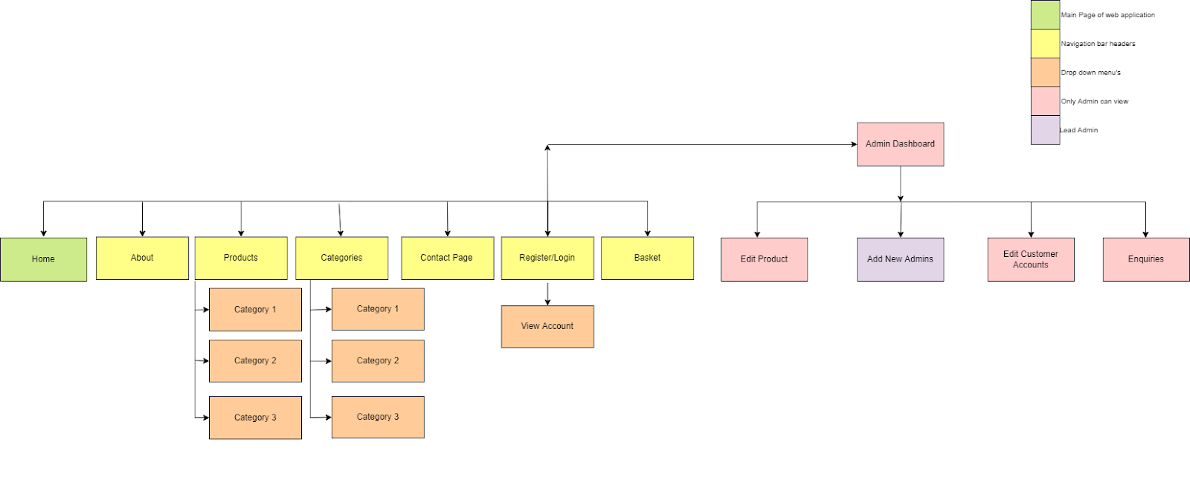

Figure Navigation flowchart

This flowchart depicts the navigational structure of the online application. Each colour has a key, with green serving as the universal home page. The heading will be displayed in yellow on the navigation bar, and the drop down choices will be displayed in orange. Once a person has logged in, the system will detect whether they are a customer or an administrator. Only an administrator will be able to see these websites, as shown by the red colour. The purple colour represents the lead/main admin, who has complete power over the web application.

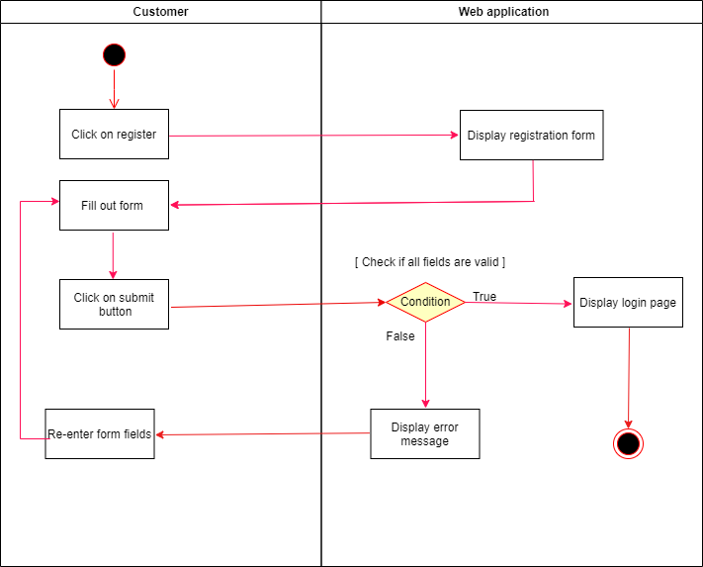

Figure Registration activity diagram

The activity diagram shows how a customer can register on the web application. Firstly the customer will click on the navigation bar where it will display the heading register. After the customer fills out the registration form, the web application runs a condition to see if all of the text fields are valid. If the text fields are correct, the login page will appear; if they are incorrect, an error message will show, prompting the customer to re-enter the registration form.

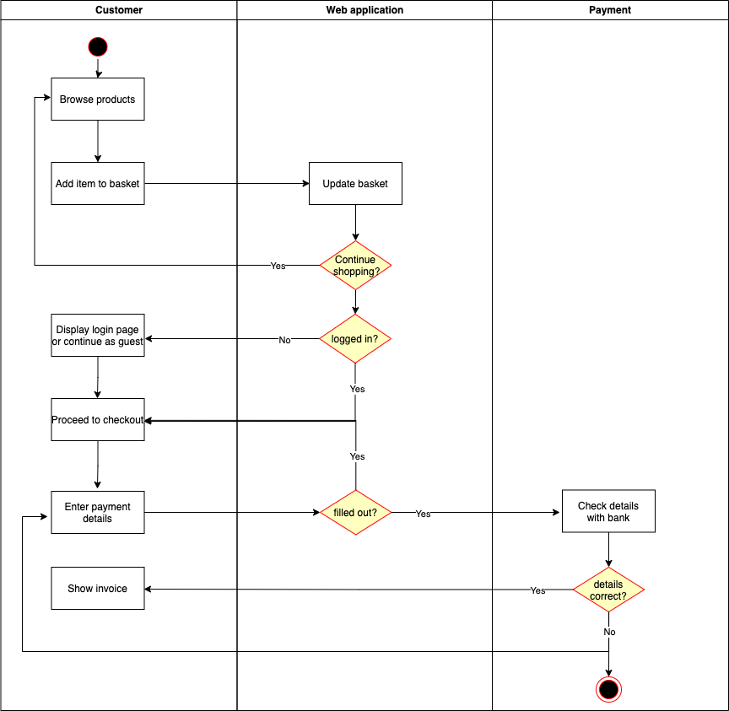

Figure Payment activity diagram

This activity diagram shows the process of buying a product. Firstly, a customer will browse the products on the web application and add an item to the basket. Then, the web application will update the basket and display It to the user. It will then also ask the customer if they would like to continue shopping, if they press yes, they will be redirected to the products page, if no, it will check if the customer is logged in. If the customer is logged in, it will forward them to checkout, if they are not logged in, it will display a login page, where they can either log in or decide to continue as a guest. After that, they will also be sent to the checkout page. The user then has to enter their payment details and pick a payment method. After submitting this, the web application checks if all of the fields are filled out. If they are, the card details will be checked with the bank to confirm payment, if the fields are not filled out, the user is sent back to entering their payment details. After payment was submitted, and the bank has approved of the check, the invoice will be displayed. If the details entered are incorrect, the customer will be redirected back to entering their payment details until the payment goes through.

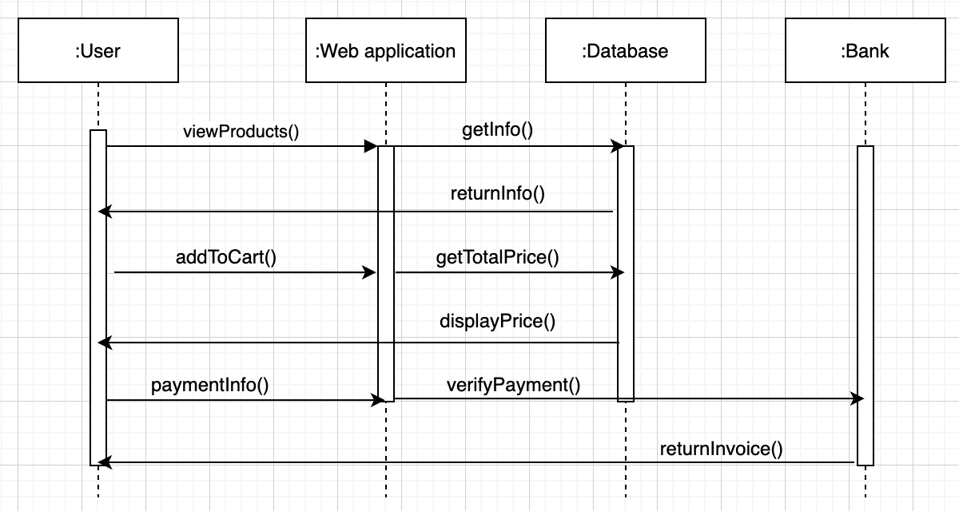

Figure Payment sequence diagram

This is a sequence diagram, displaying the way the web application operates when a customer buys a product. The customer will first be viewing the products, which will call a function to get the description of the product with its images from the database, and this will then be presented to the customer that is browsing the products page. The customer can then add one, or multiple items to the cart, which will call a function to calculate the total price. After that, the customer has to enter their payment details, which calls a function to verify the payment. When the payment goes through, an invoice is returned, which lets the customer see all of the order details.

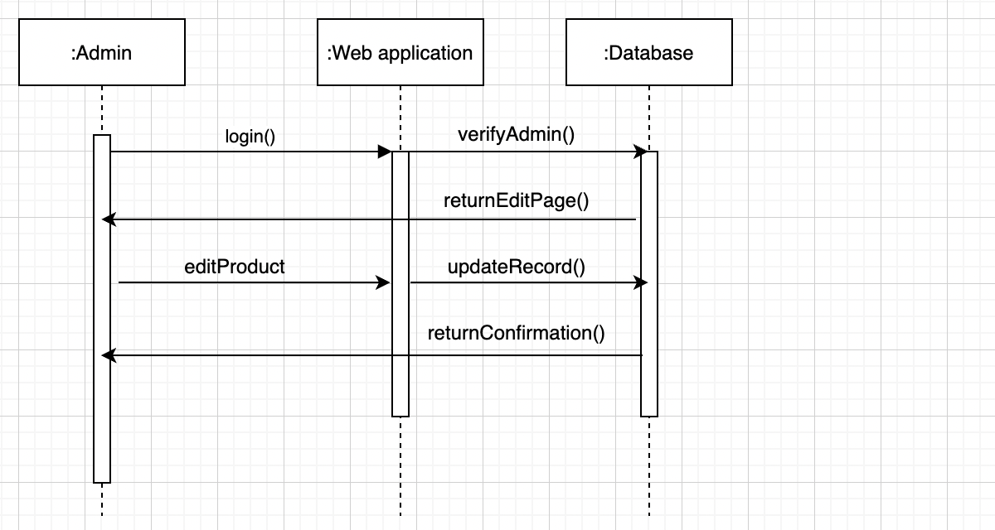

Figure Edit product sequence diagram

This is a sequence diagram that explains how an administrator can edit a product. They must first log in, which will be validated by the web application by looking up the account's entry in the database. Only admins are authorised to edit products, hence a regular user account is unable to do so. After verification, the admin will be taken to the edit page, where they can change the title, price, or description. The database record will be updated after you submit this, and a confirmation message will appear on the screen.

This diagram also explains how you could edit a category, as both follow the same steps. For editing a category you also need to be an administrator account, which will then allow you to change the categories title, or add a new one.

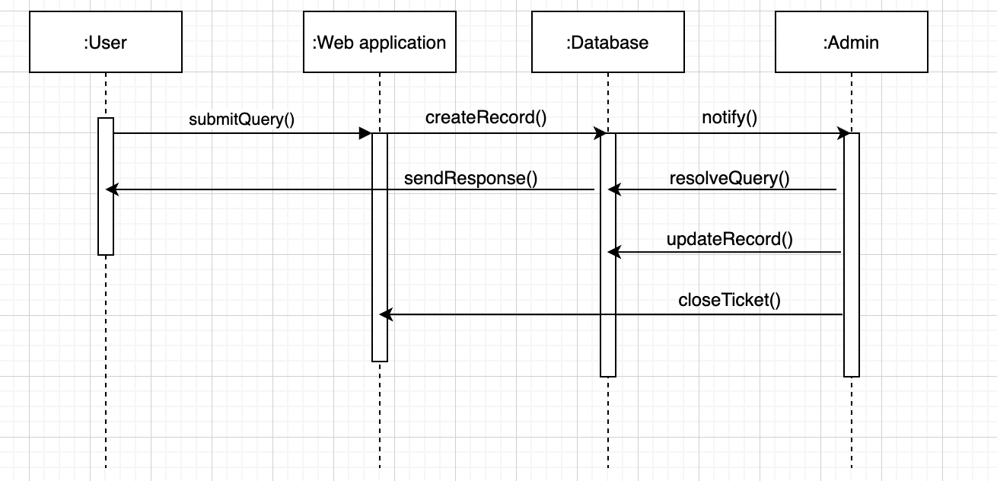

Figure Submit a query sequence diagram

This sequence diagram shows the process of a customer submitting a query. Submitting a query will create a database record and notify an admin for them to resolve it. Once the admin responds to it, the message from the administrator will be forwarded to the user. Then, the database record is updated with the message from the admin as well as the name of the admin that resolved it

## Wireframes

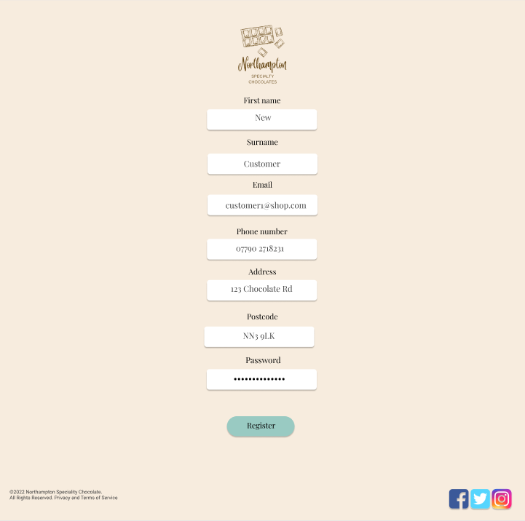

Figure Register wireframe

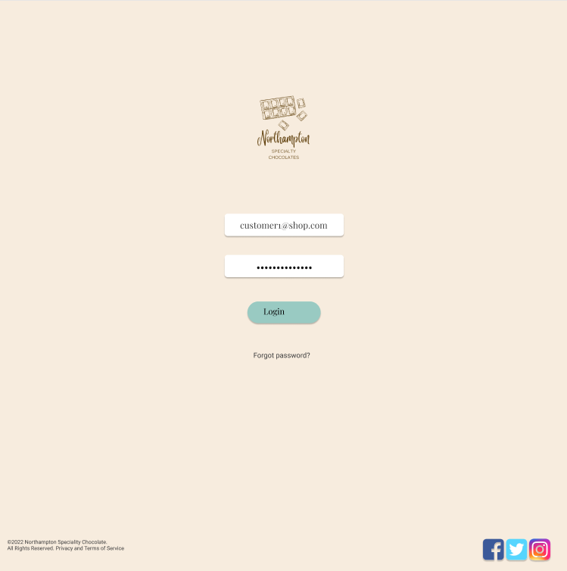

Figure Login wireframe

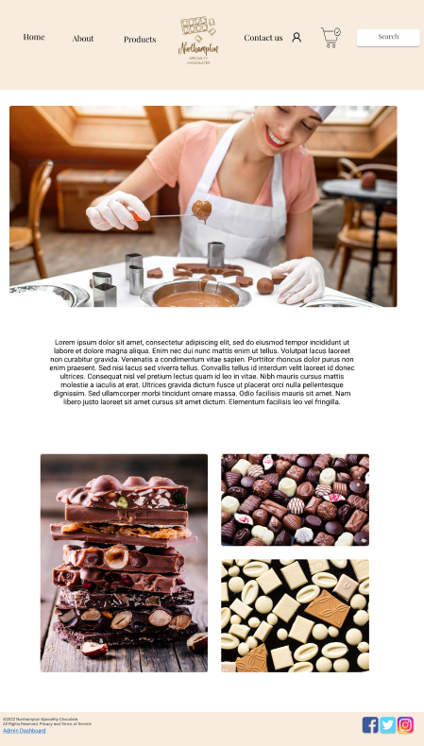

Figure Homepage wireframe

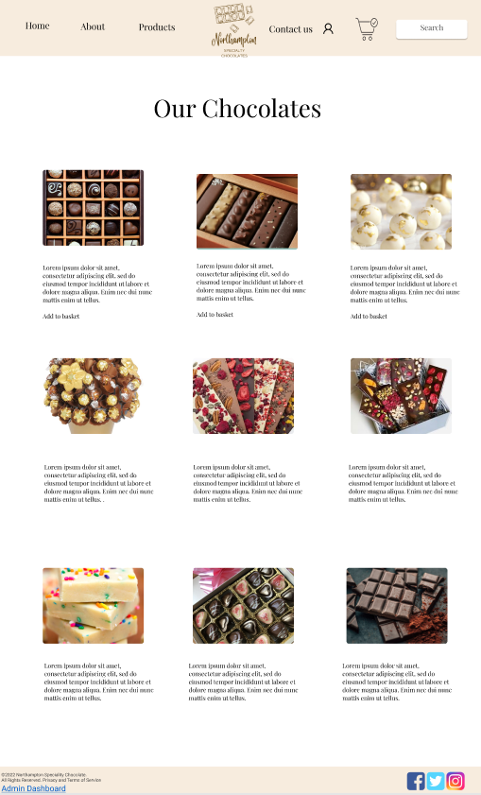

Figure Products wireframe

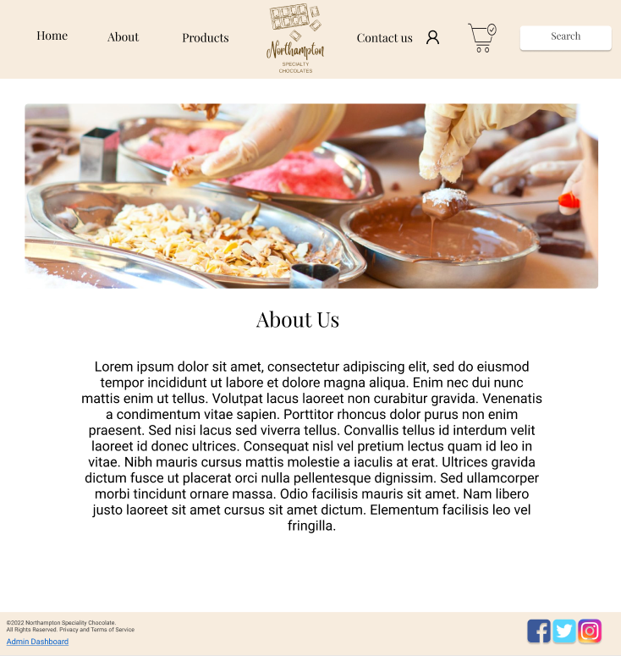

Figure About us wireframe

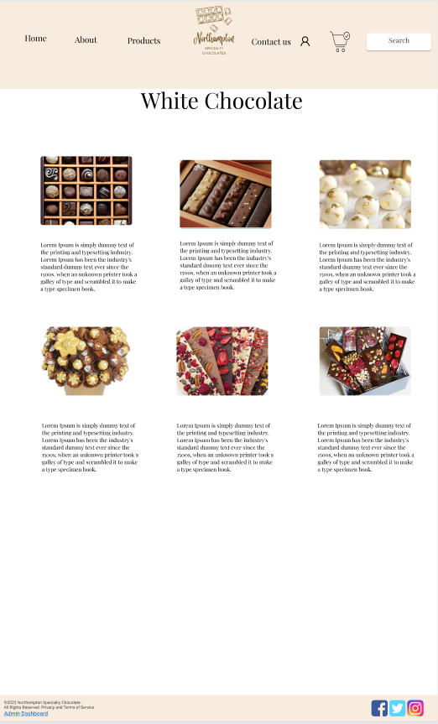

Figure White chocolate category wireframe

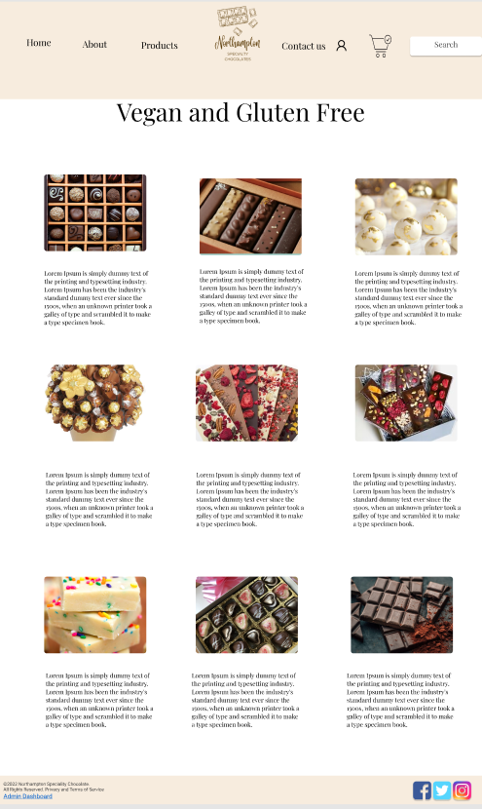

Figure Vegan and gluten free category wireframe

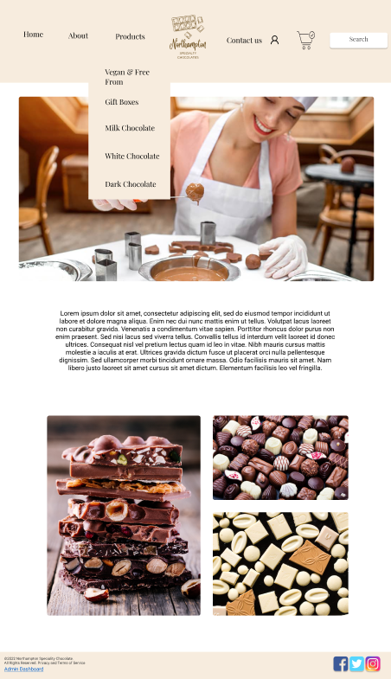

Figure Homepage navigation bar options wireframe

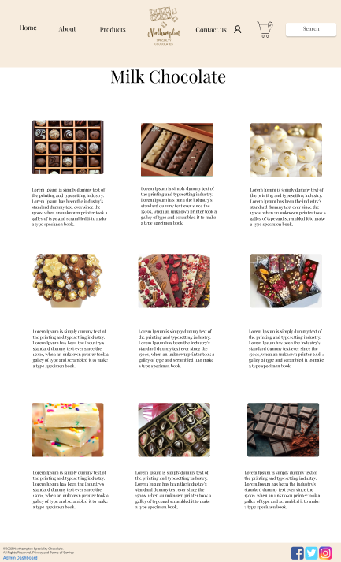

Figure Milk chocolate category wireframe

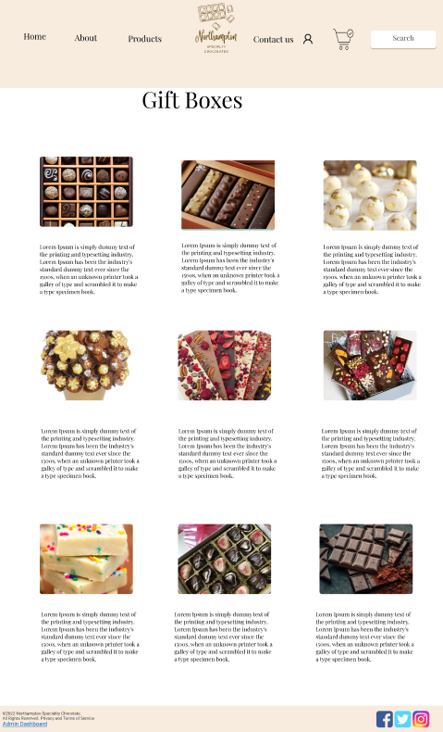

Figure Gift boxes category wireframe

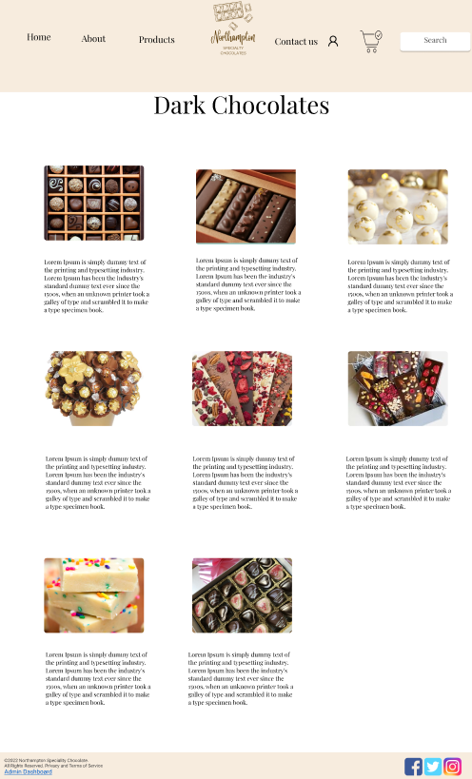

Figure Dark chocolate category wireframe

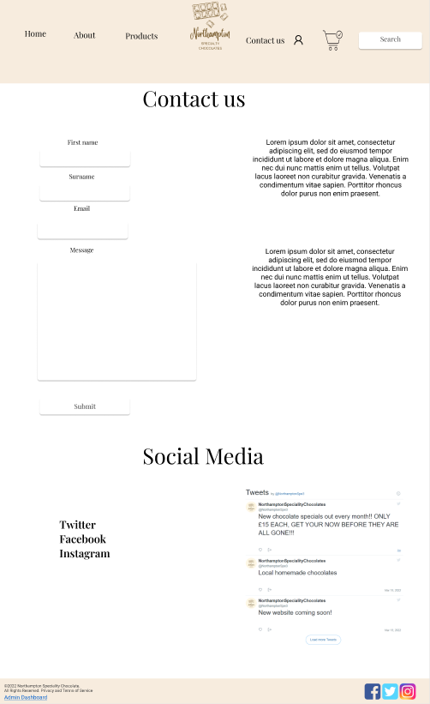

Figure Contact us and social media wireframe

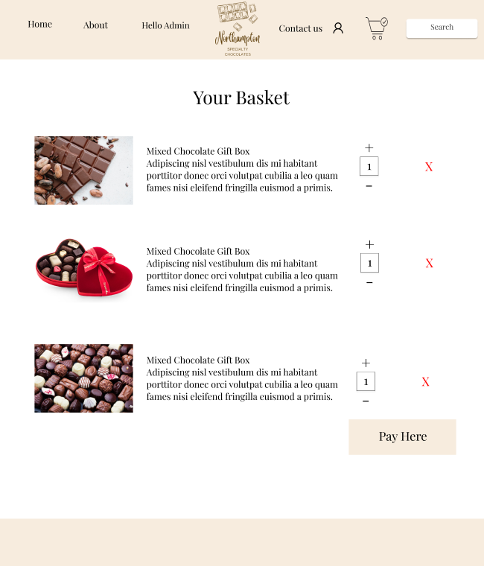

Figure Basket wireframe

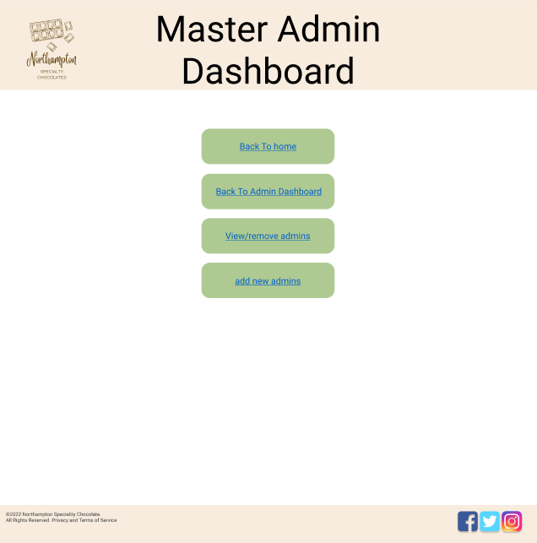

Figure Master admin dashboard wireframe

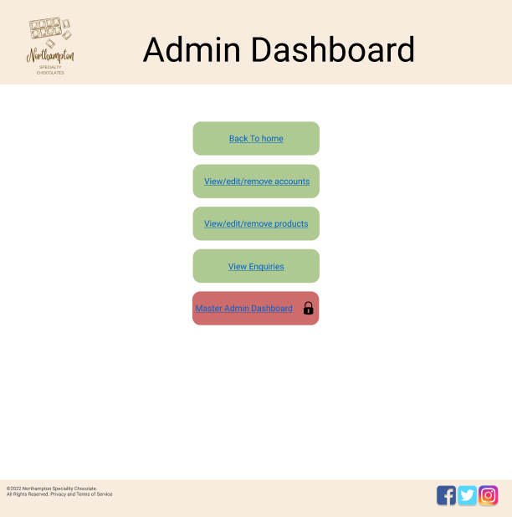

Figure Admin dashboard wireframe

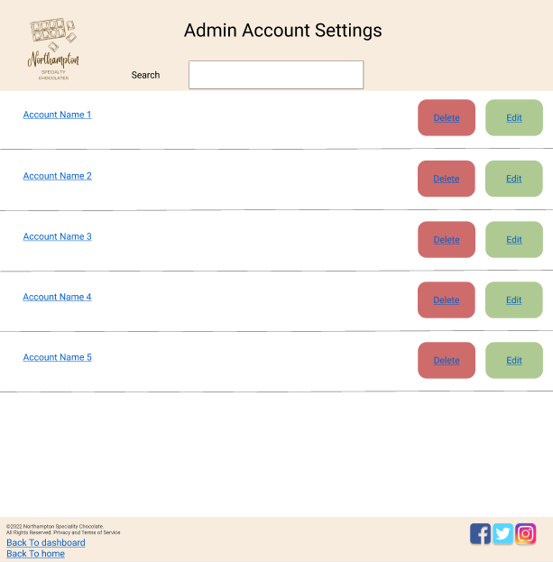

Figure Master admin add account wireframe

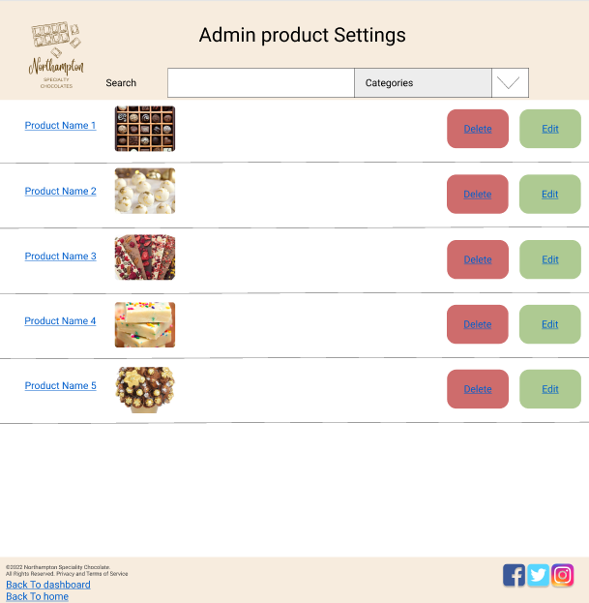

Figure Add products wireframe

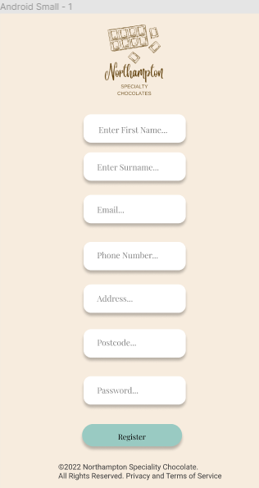

Figure Mobile register wireframe

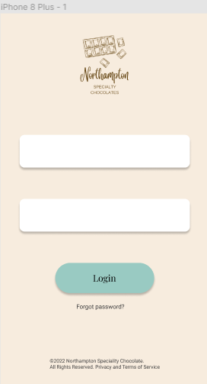

Figure Mobile login wireframe

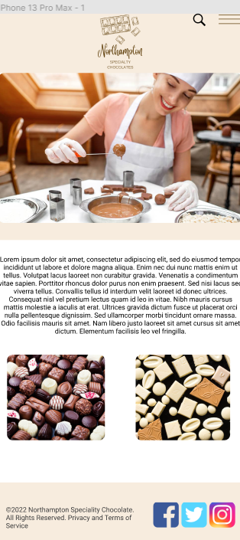

Figure Mobile homepage wireframe

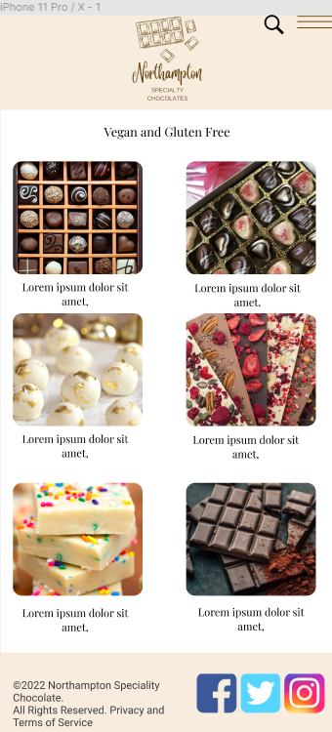

Figure Mobile vegan category wireframe

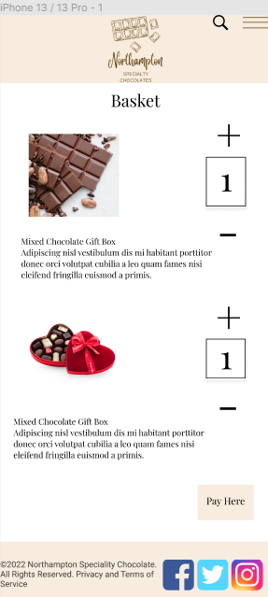

Figure Mobile basket wireframe

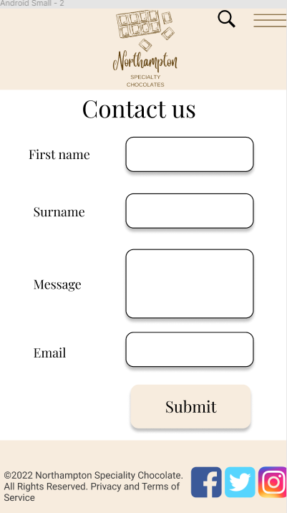

Figure Mobile contact us wireframe

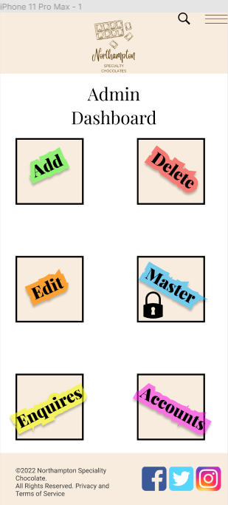

Figure Mobile admin dashboard

## ERD

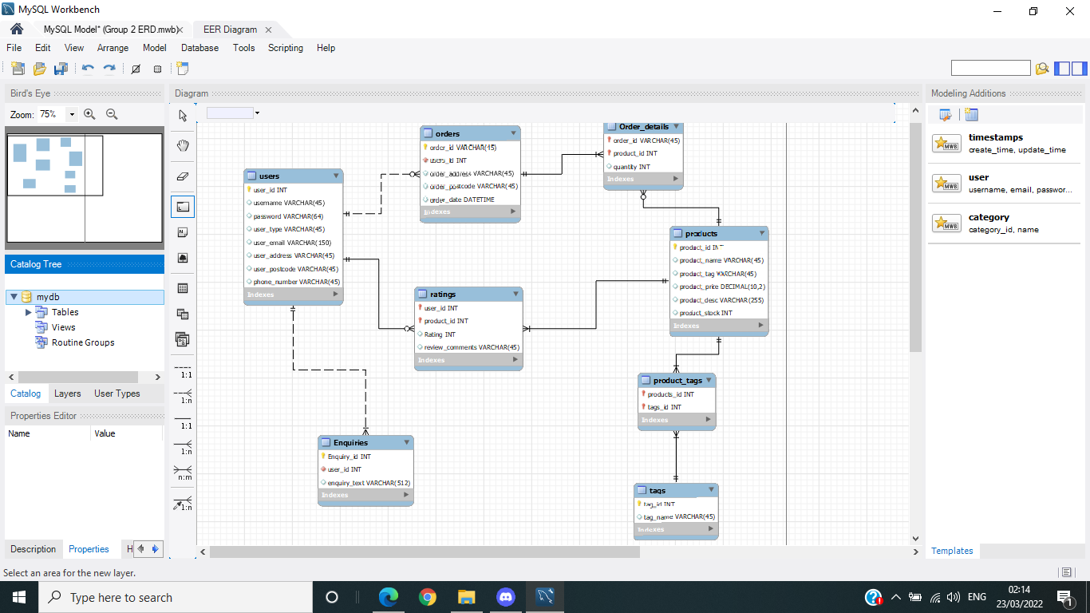

Figure ERD

Users

The users table will be used to hold data on the users such as their username, address, passwords and contact number. For security reasons any of the user's sensitive data such as their passwords will only have their hashed version stored on the database.

Enquiries

The enquiries table holds the data from any and all user enquiries and whether the enquiry has been resolved.

Rating

The ratings table has the data for the product reviews, this will include the users review and their star rating.

Orders

The orders table holds the data for the received orders, this will include the id of the user who placed the order, the delivery address and the id of the order.

Order Details

The order table links the orders and product table.

Products

The products table has all the data relating to any of the products on the site including the name, the tags relating to the product, the products price and its description.

Product Tags

The product tags link the products and tags table and will consist of the product and the tag id.

Tags

The tags will hold the tag types e.g white chocolate or milk chocolate.